Teddy Bear Hospital
Library of Birmingham
Contact: Linda Monk (Linda.Monk@birmingham.gov.uk)
Target ages: families; KS1 (5-7 years old)
Summary
A collaboration between Library of Birmingham and a local student charity to deliver sessions in the library aimed at making children less fearful of visiting doctors and dentists and have a range of health and wellbeing themes.
Partners
Teddy Bear Hospital (http://uobmedsoc.com/teddy-bear-hospital/
Description
The library used to do a lot of outreach but are unable to do so now because of staffing arrangements. When they moved to their new building, they were approached by the students who are all going on to be health practitioners and whose charity has a number of aims:
- Help children (aged 3-7) become less fearful of visiting doctors and dentists
- Teach children about key, basic themes for a healthy and happy life (healthy eating, dental hygiene, road safety, body confidence, physical activity)
- Get children to talk about their experiences with illness, doctors and medicine
A sub-theme for the students is to provide opportunities for medical students to improve communication skills with young children.
The child plays the part of the parent bringing their sick teddy to the hospital, the teddy is diagnosed by a teddy doctor (The student) and the child receives a 'pawscription' for their teddy.
The healthy eating, dental hygiene, road safety, body confidence and physical activity themes are set up as stations at a TBH workshop and the children go round the stations and learn the different skills. The children are taught in an interactive way using posters, models and toys to help them understand.
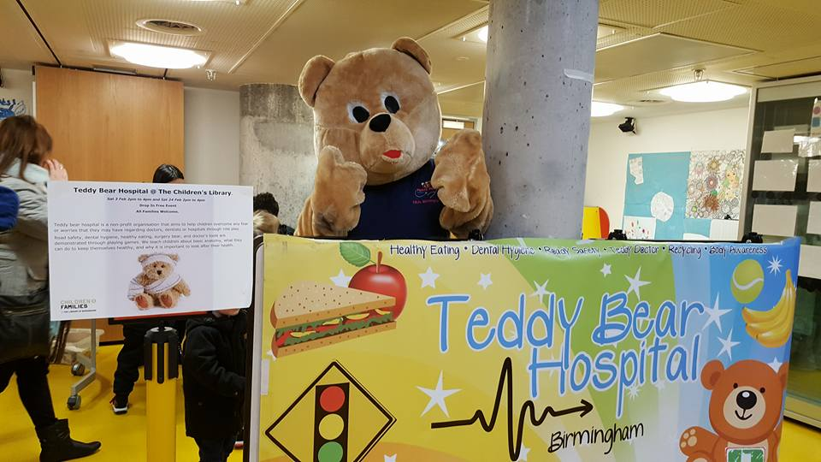
Sometimes summer reading challenge and record breakers themes have also lent themselves to doing bespoke sessions.

The library reports that the sessions go very well and that they have had really good feedback from customers. An additional benefit is that there is limited resource input from the library because they do not have to provide staffing or security for event.
The sessions are deliberately run on Saturdays and holidays to maximise attendance and they tie in well with the event programme they organise for school holidays.
Cost – very low to none
Top tip: similar sessions could be organised in partnership with other health professional trainees/students

