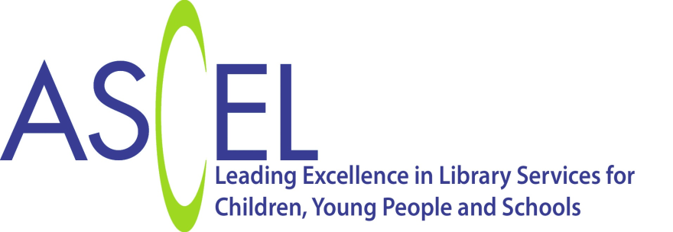
Statement on Arts Council England: Cultural Education Challenge
ASCEL (the Association of Senior Children’s and Education Librarians) welcomes the Cultural Education Challenge. We believe a coherent wrap-around cultural education offer that connects schools and communities and links them with arts and cultural organisations will ignite curiosity, remove barriers, and enable children and young children to pursue their dreams.
ASCEL’s Children and Young People’s Promise, highlights the library offer to children and this includes the opportunity “to take part in a wide range of literacy and cultural experiences including reading and book-based activities.”
There are public libraries in most communities, and for some children, a library is the first cultural organisation they experience as they enjoy rhymes and songs at rhyme times.
Public Libraries along with School Library Services contribute to cultural education by giving children access to our rich heritage of children’s authors and illustrators and engaging them in creative reading programmes working with organisations promoting reading such as Booktrust and The Reading Agency.
Libraries are also enthusiastic cultural partners accustomed to working with other arts and cultural organisations as well as schools, youth organisations and health services to develop quality arts and cultural activities.
Current examples of public library activities include a national partnership with the Shakespeare Birthplace Trust to celebrate Shakespeare’s 400th anniversary; working locally and regionally with Arts Organisations including National Portfolio Organisations and collaborating with with Music Hubs to boost speech and language through rhyme times.
The Cultural Education Challenge will enable public and school library services to contribute fully to an integrated arts and cultural offer in their communities and we look forward to participating in the pilot areas.
Sarah Mears, ASCEL Chair, April 2016
‘We are delighted that the library sector is contributing to delivering the Cultural Education Challenge, encouraging children from all backgrounds to engage in the arts. This more coherent delivery of cultural education supports the Arts Council’s ambition of ensuring every child and young person has the opportunity to experience great art and culture. We look forward to seeing what can be achieved and hope more libraries will be inspired to take part.’
Laura Gander-Howe, Director, Learning, Arts Council England

