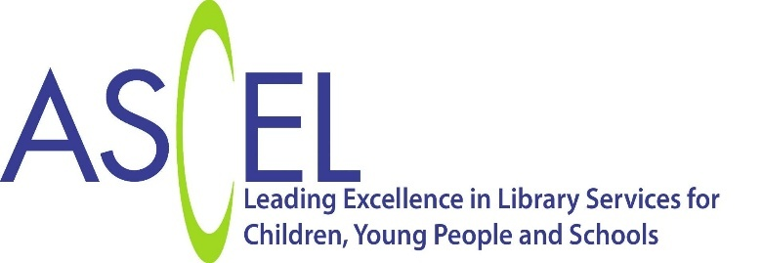

Communications and Impact Manager Application Form

Please tell us about your experience of strategic communications, campaign management and advocacy.
(250 words max)
This box will expand as you type

Please tell us about any experience of research and evidencing impact to key stakeholders.
(250 words max)
This box will expand as you type

Please tell us about the approaches you have taken to successfully deliver a communications strategy or campaign, noting the impact it generated.
(250 words max)
This box will expand as you type

Please tell us about how you have used communications and stakeholder engagement skills to raise awareness of important issues.
(400 words max)
This box will expand as you type

Please tell us why you have applied for this position and what approach you will take to ensuring our charity achieves its strategic goals.
(500 words max)
This box will expand as you type

