Storywalks
Kirklees Libraries
Contact: Tiffany Haigh (tiffany.haigh@kirklees.gov.uk)
Target ages: families; KS1 (5-7 years old) and below
Summary
Family activity walks in local areas organised by library staff and volunteers. Walks can start at and end at a library or community based e.g. in a park. Themed walks with an increasing emphasis on contribution to Health Literacy in Kirklees.
Partners
Kirklees Physical Activity Development Team
Kirklees Libraries Friends of…Groups and volunteers
Children’s Centres
Schools
Description
Family storywalks, combining exercise with book-related activities, have developed from simple picture hunts during a walk, to a tool used to build relationships with communities, deliver high-quality events at low cost and engage with hard to reach groups.
A storywalk is an opportunity to bring books out of the library, to promote reading and libraries in an alternative environment, to bring stories to life and allow families to combine reading with physical activity. Storywalks give children the opportunity to develop literacy skills while playing and ensure the whole family partakes in fun, healthy outdoor exercise.
Storywalks can be themed e.g. a bat walk for Halloween or to tie in with the Summer Reading Challenge. Kirklees has also developed a more targeted approach e.g. working with a children’s centre is located on a council estate that falls in the bottom 10% for deprivation in the UK.
More detailed information is available at https://librariestaskforce.blog.gov.uk/2017/06/16/family-storywalks-in-kirklees/
Storywalks have been very popular with over 1500 participants since April 2015 and are inclusive reaching an audience wider than existing library users.

Types of storywalks
- Picture trails: involve a treasure hunt themed around a children’s picture book. The event usually starts with reading the book and then children look for characters or elements from the book that have been hidden around the outdoor space. The whole event could take place in a park, or the pictures could be along the route between the library and another community venue. Can include a craft element, sometimes using items found in the natural environment
- Nature hunts: an innovative way to engage children with non-fiction resources. Children involve learning about habitats and wildlife by exploring local outdoor spaces as a family, discovering where to find wildlife and view it up close. Junior non-fiction resources are used to find out more about the wildlife discovered.
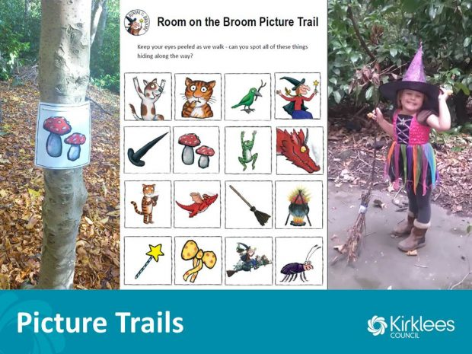
Getting prepared and resources needed
Storywalks have two Walk Leaders – at least one has received walk leader training (from the Kirklees Physical Activity Development Team). These can be staff or volunteers. Children must be accompanied by a parent or carer.
Walk Leader Training includes: planning the route, managing the walking group and how to carry out a route risk assessment before the walk.
Staff and volunteers have also received training from Purple Patch Arts to improve story telling skills and create a more sensory experience and make stories accessible to children with additional needs. (http://www.thelocaloffer.co.uk/providers/purple-patch-arts).
Kirklees have developed backpacks for use on storywalks containing essential equipment and visual aids, and leaders have reflective jackets.
Cost
Storywalks are low cost. Walk Leader training is provided free by another council department. High visibility jackets are recommended. Existing library resources can be used to support the walk.
Additional costs can include supplementary training (Purple Patch is a charged for service), additional resources to support story telling and bug hunting, advertising and refreshments.
Top tip: good route planning is essential. People will turn up in all weathers so make sure you have suitable coat and shoes for the conditions

