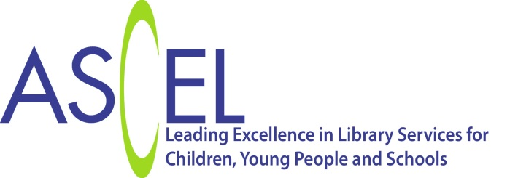

What to read with a two year old? – librarians to the rescue

Philip Ardagh has written an open letter to Simon Cowell in response to his comments that the books he is reading to his son are “quite boring”. Philip said “A good librarian can point you in the direction of some amazing books for your son. There really are some wonderful children’s books waiting to be shared, and a professional librarian can help you access them”.

ASCEL never can resist a challenge and we’ve enlisted librarians across the country to provide a list of stories which have been tried, tested and loved by two year olds.

We love to see dads sharing books with their young children. Books for two year olds need to be immediately appealing. They also need to offer reassurance and familiarity, as well as new experiences. They should feature strong, memorable characters to help children build their emotional skills and support speech and language development. Above all they should be fun for children and their parents.

We hope Simon and Eric enjoy some of the great books in this list –available of course -from local libraries.

Sarah Mears
Chair ASCEL: The Association of Senior Children’s and Education Librarians

Is that my cat? - Jonathan Allen
Pants – Giles Andreae
Please, Mr Panda - Steve Antony
Snip Snap – Mara Bergman
The very cranky bear – Nick Bland
Ten Little Mermaids – Stephanie Boey
Love monster- Rachel Bright
Mr Tiger goes Wild - Peter Brown
Never tickle a tiger - Pamela Butchart
This dog just ate my book - Richard Byrne
Dear Zoo – Rod Campbell
Hungry Caterpillar – Eric Carle
Lunchtime – Rebecca Cobb
The Gruffalo – Julia Donaldson
Dandylion – Lizzie Finlay
Aliens love Underpants – Claire Freedman
Doing the washing –Sarah Garland (and others in the series e.g. Going shopping)
Again! – Emily Gravett
Monkey and Me – Emily Gravett
Oh no, George - Chris Haughton
Rosie’s Walk – Pat Hutchins
Kipper – Mick Inkpen
Poppy Cat - Lara Jones
I Want My Hat Back – Jon Klassen
Hugless Douglas - David Melling
The Crocodile that Didn’t like Water – Gemma Merino
Peace at Last – Jill Murphy
My Big Shouting Day – Rebecca Patterson
The Jjurney home- Frann Preston-Gannon
We are going on a Bear Hunt - - Michael Rosen
Dr. Seuss’ Sleep Book - Dr Seuss
Shark in the Park- Nick Sharratt
Red Car, Red Bus – Susan Steggall
Interrupting Chicken – David Ezra Stein
How to hide a lion – Helen Stephens
Banana – Ed Vere
That’s not my bear - Fiona Watt (and others in the series e.g. That’s not my dinosaur; That’s not my mermaid)
Tanka Tanka Skunk – Steve Webb
Poles Apart- Jeanne Willis

www.ascel.org.uk
@ASCELUK

